G–SUITE METRICS

CSC 505/605 FALL 2019

By: Advisor:

Lavanya Goluguri Dr. Somya Mohanty

Anusha Vanama Mentor:

Jackie Cuong Nick Young

Henry Reichard

Hieu Vo

INTRODUCTION:

DATA DESCRIPTION:

Our G-suite metrics data set from ITS at UNCG. It gives us information about G-suite services usage, for all the users across an entire domain. Here the data is collected for the UNCG users that is automatically pulled into Splunk from Google. Some of the G-suite services include Google Accounts, Google Calendar, Google Hangouts, Gmail, Google+, google drive/docs, Chrome OS devices, Google sites, Mobile devices google applications etc. The information is organized by application type which composed of parameters specific to that application.

If we consider the data set it is in .CSV format. The data set size is 611,914 rows.

The date is collected from March 23rd , 2015 to August 17th, 2019. It has three attributes:

Time - The day for which the data is collected. (format: yy-mm-dd hr:min:sec:msec)

Metric_Name - it is name of the google service used with their parameter.

Metric_Value - It is no. of. users the metric has on that day.

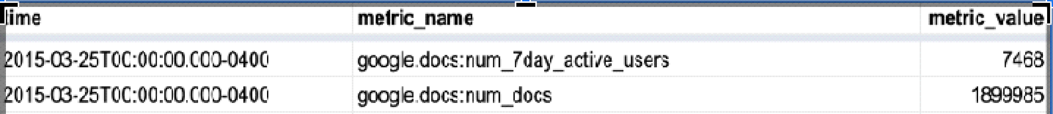

GOALS OF PROJECT:

The goals of the project include the following criteria:

1. Performing analysis on the data set, such as determining mean median and mode.
2. Finding anomalies during any of the time frames that each person is assigned to.
3. Using the data acquired to find trends and use those trends to make predictions.
4. Visualize the data and create a dashboard using Google Data Studio or Splunk.

OUTLINED TASKS:

**Lavanya Goluguri** – My task is to clean the data further and to analyze the data trends in the number of users and the metrics over period of months, In short Month by Month analysis on data. This allow me to identify the anomalies and predict trends. Helps in visualization as well.

**Henry Reichard** - My task is to data clean as well and to analyze the data in a semester by semester analysis. This will enable me to predict trends and identify anomalies with the data, more specifically find trends with the users and which Google services they are using on each semester.

**Jackie Cuong** - My task is to do week by week analysis in order to satisfy the project goals such as finding anomalies and graphic visualizations, while also searching for other creative ways to interpret and transform the data.